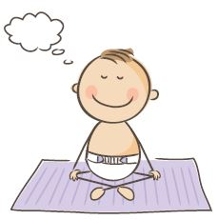
Reflections
How do you feel after the session?


What was your favourite part of the session?

What would you imagine going differently if you were to do it again tomorrow?


How do you think this content was received by the group?


What memory will you take from this session that may inform your practice going forward?

